Appendix A-1 – Thermal Conductivity of Solid using heated thermistor method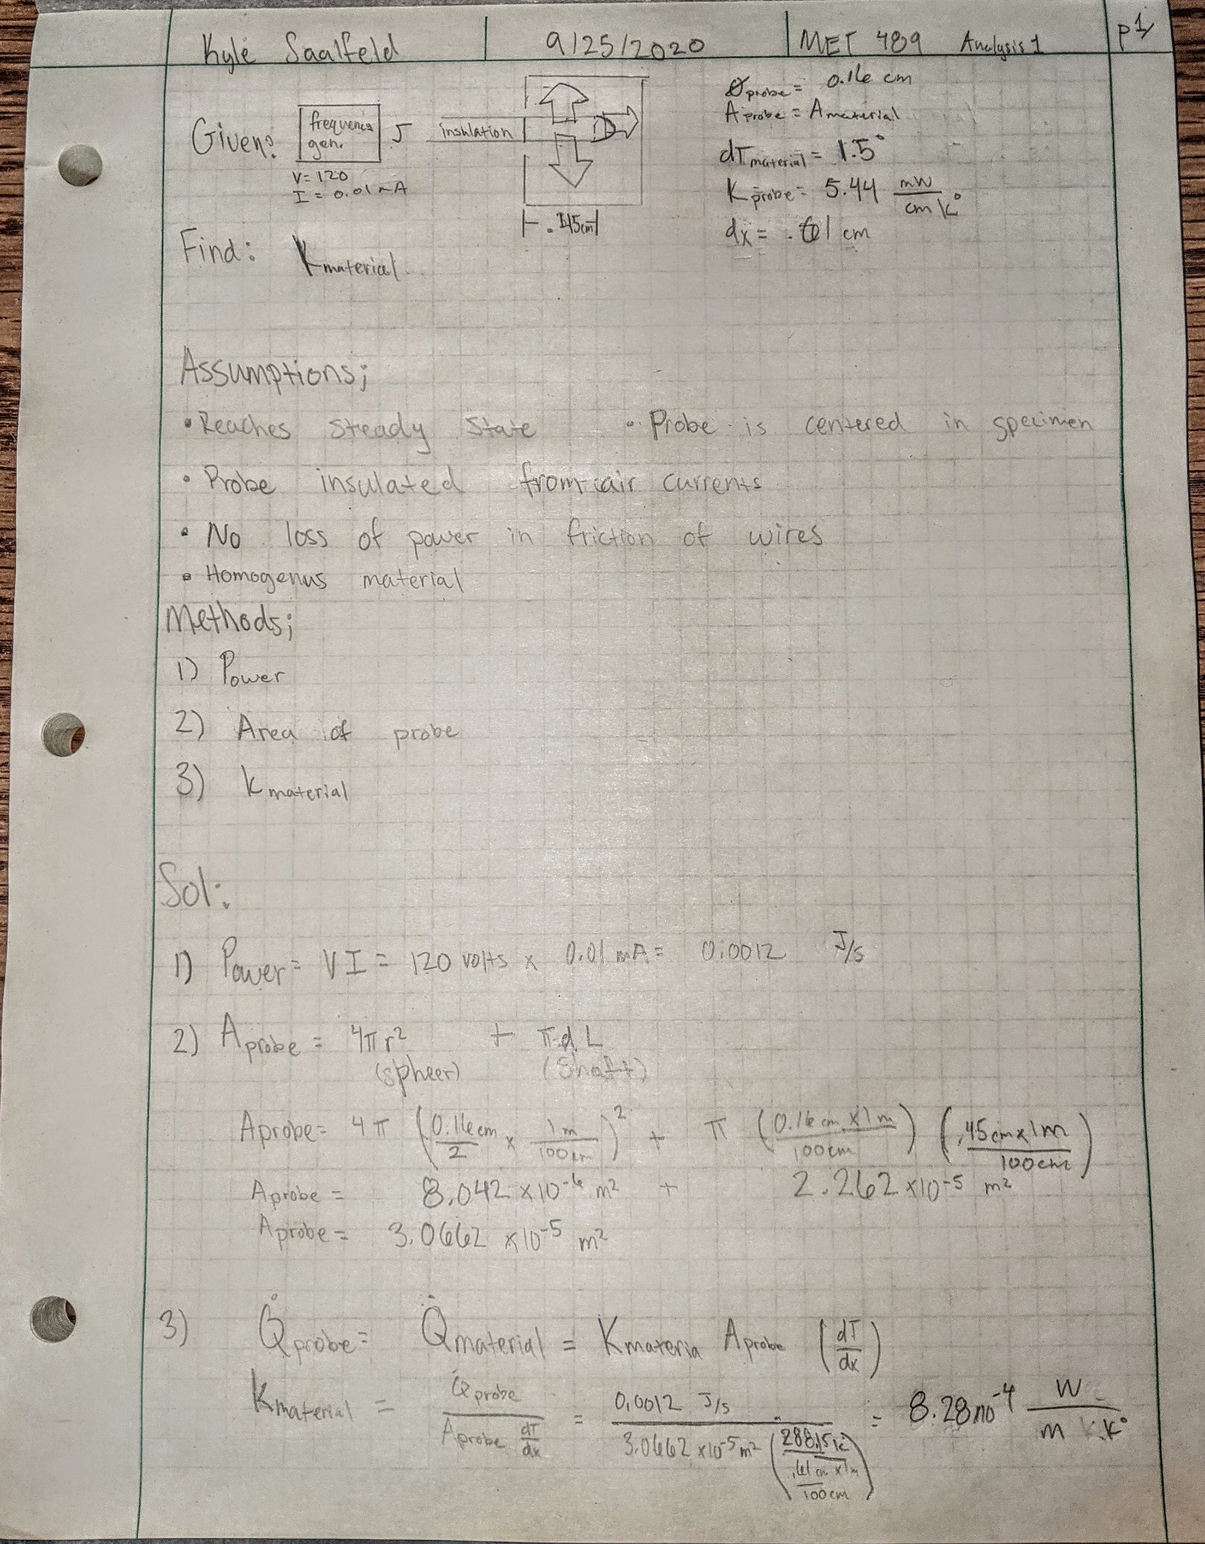
Appendix A-2 – Allowable force applied to thermistor for direct axial load 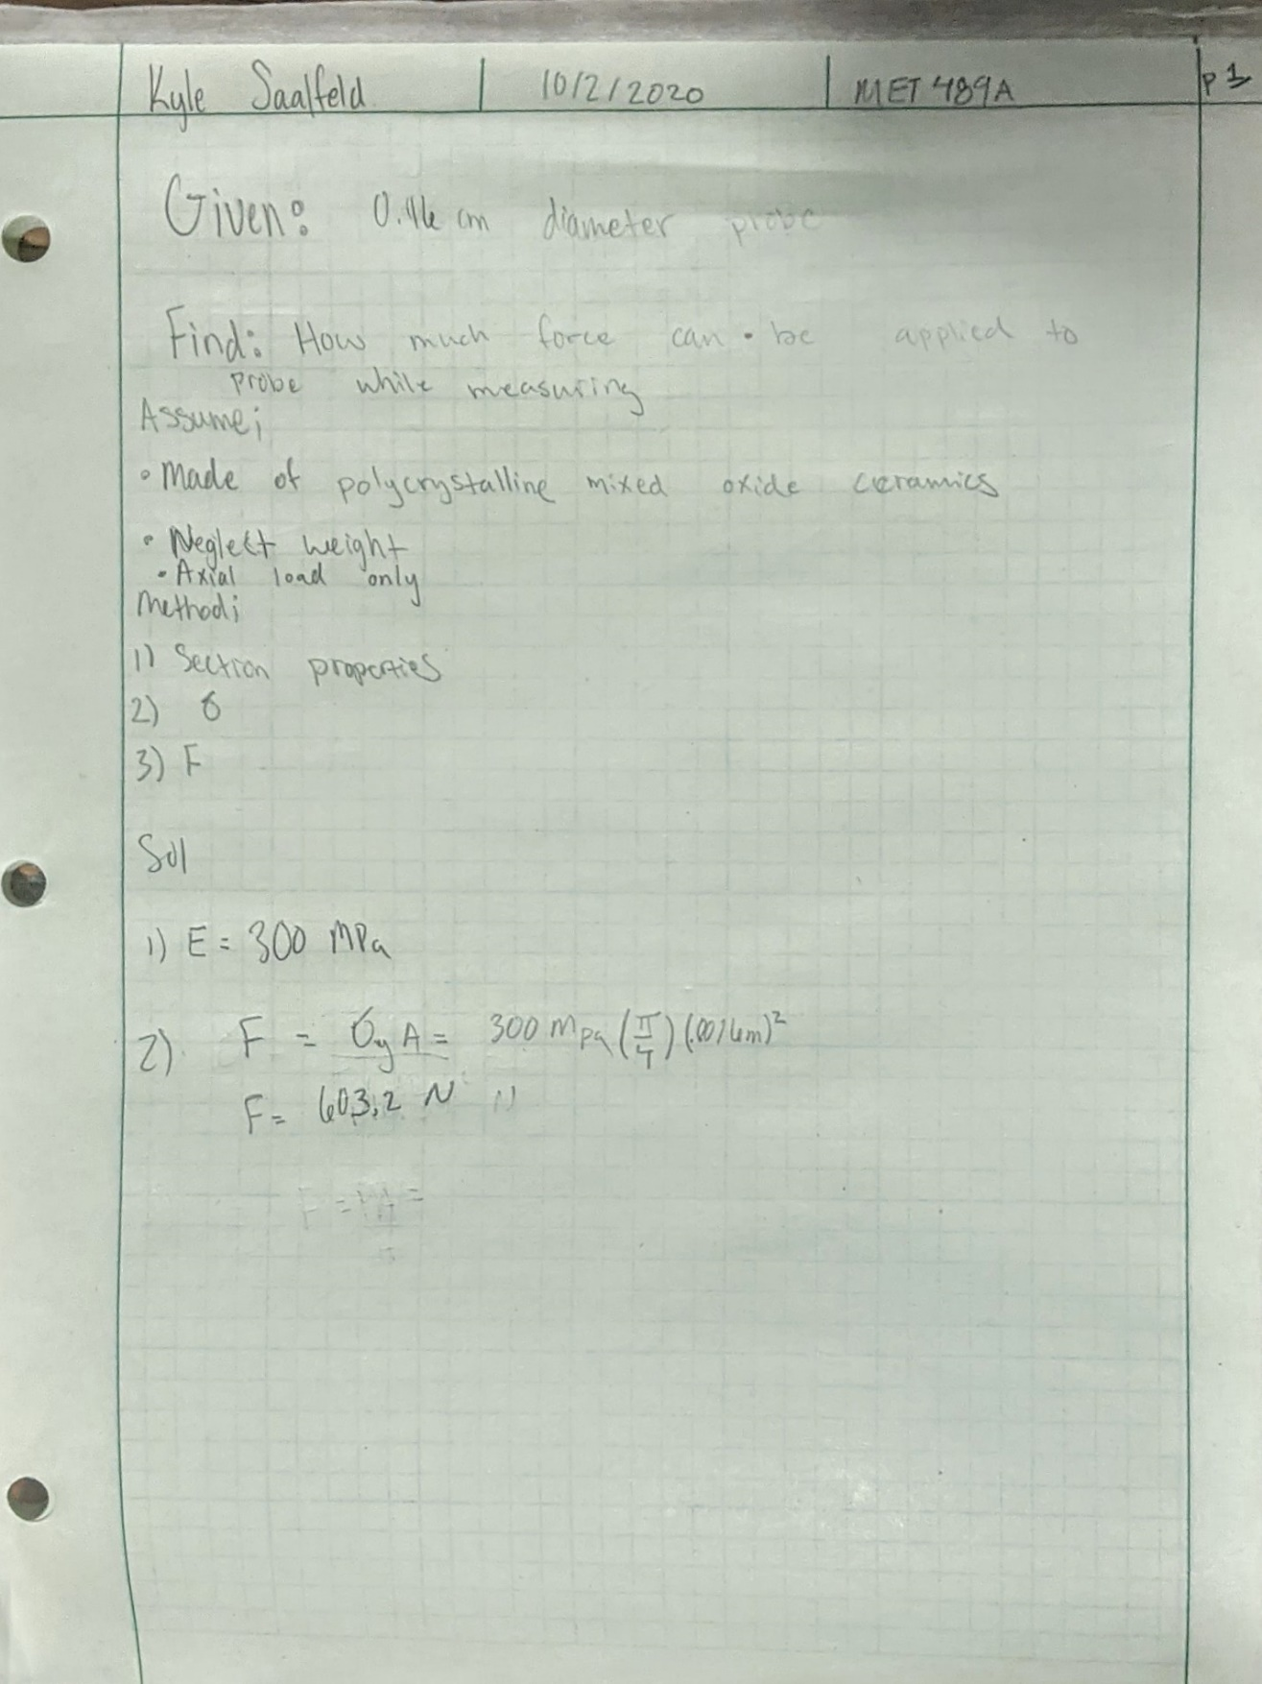

Appendix A-3- Resistivity to achieve 5% error 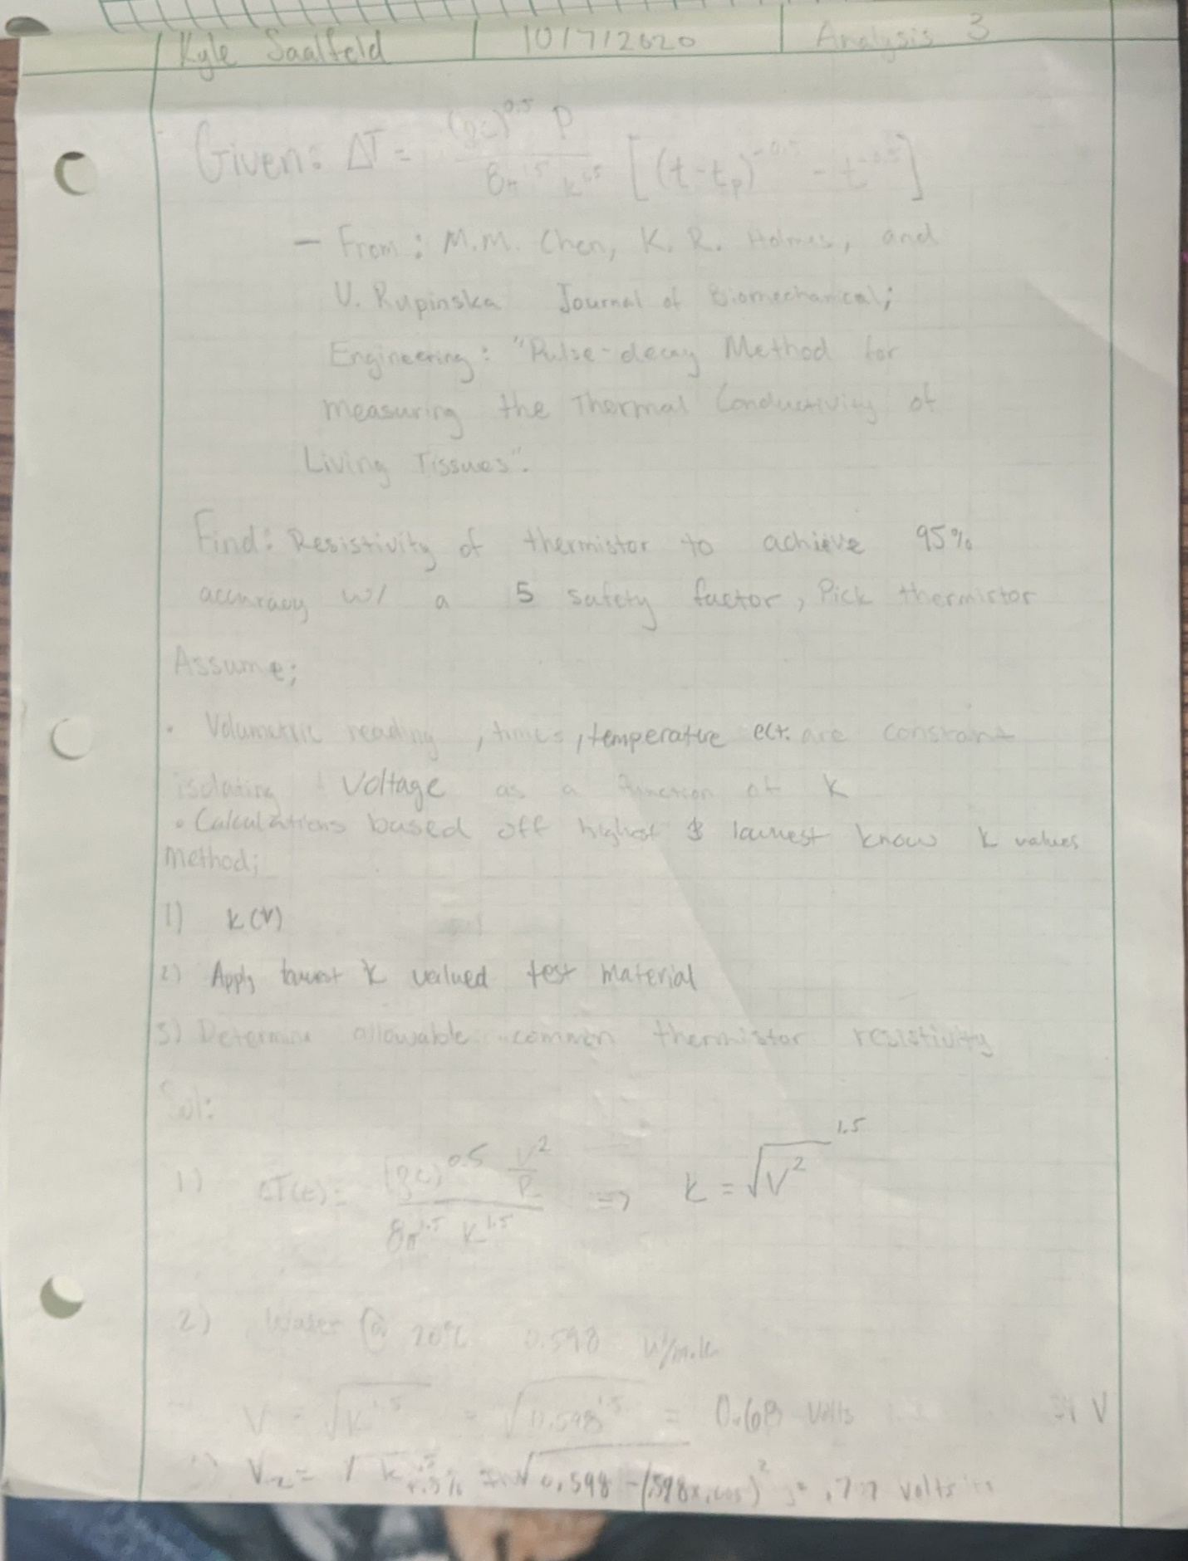 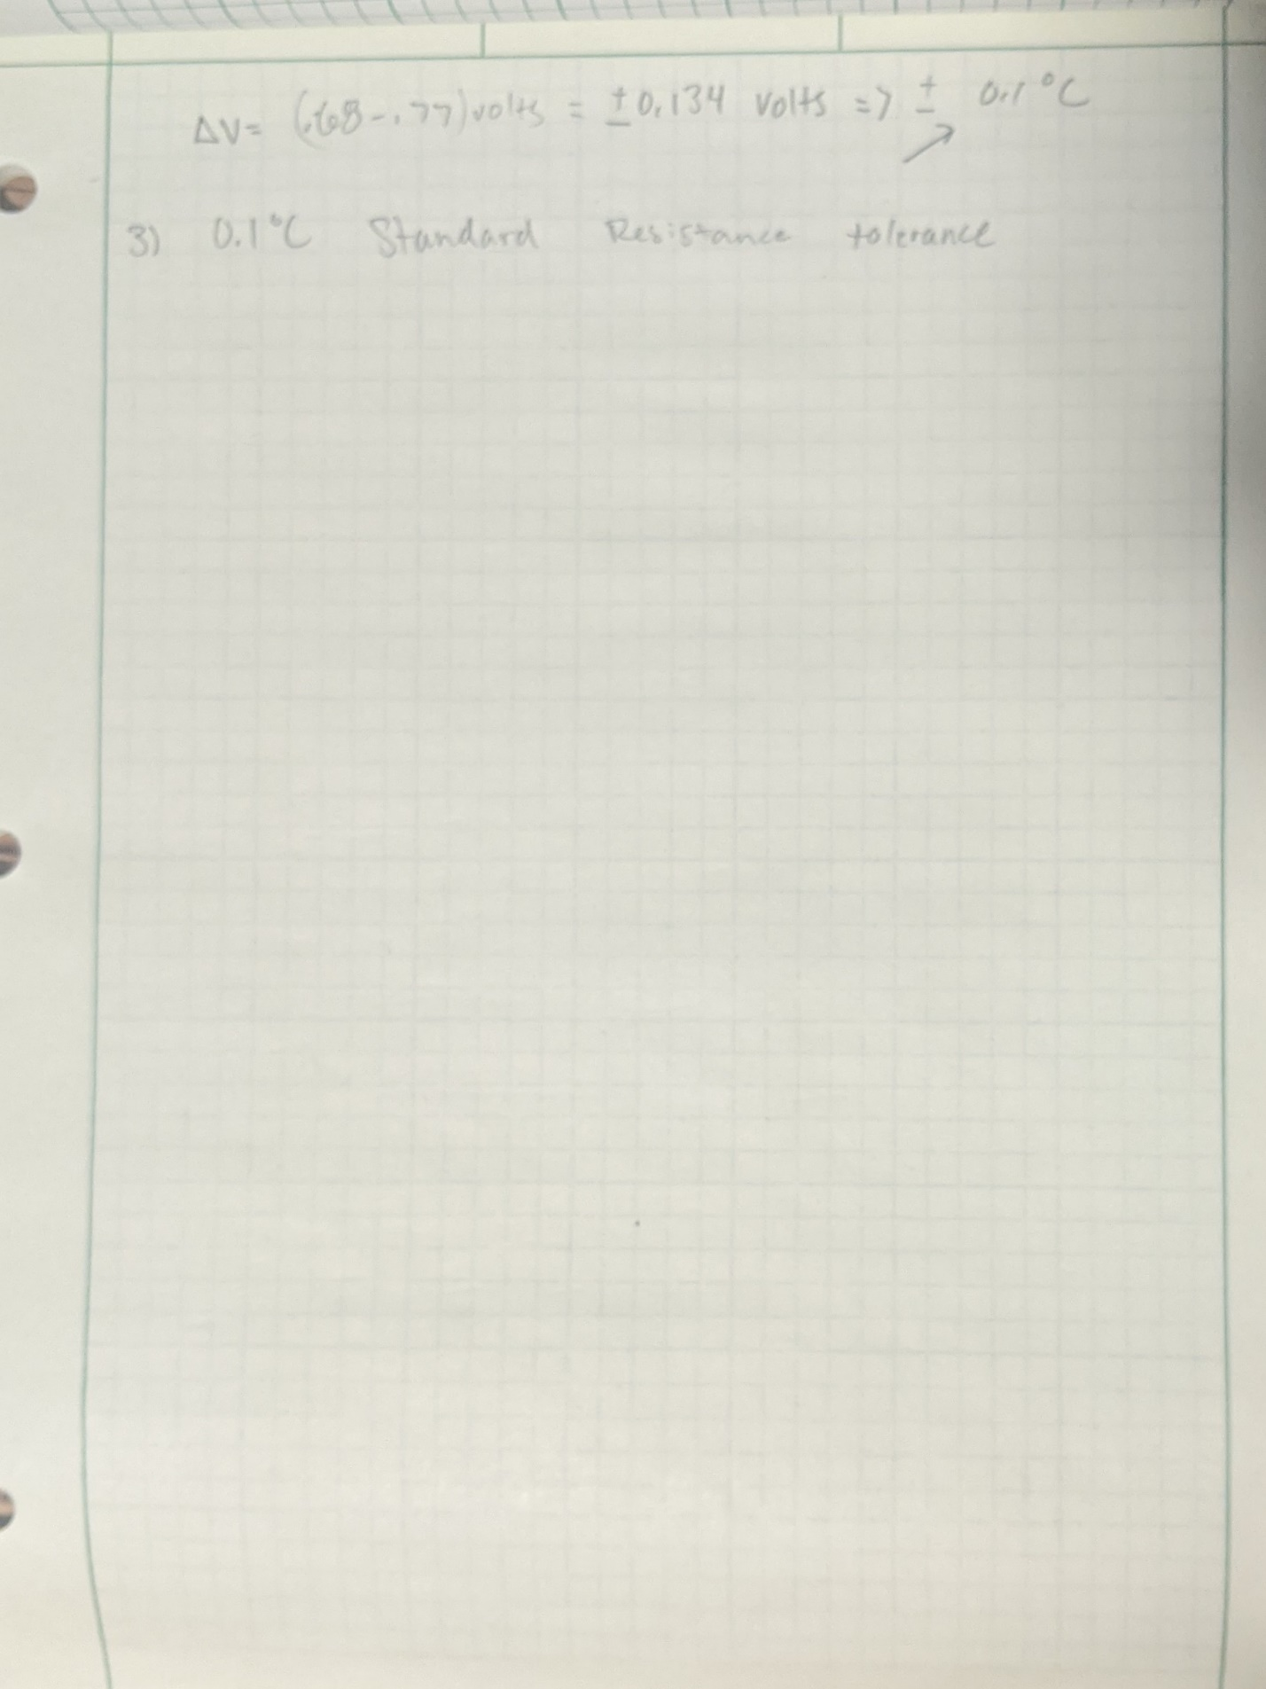

Appendix A-4- Liquid housing/ puncturer outter diameter

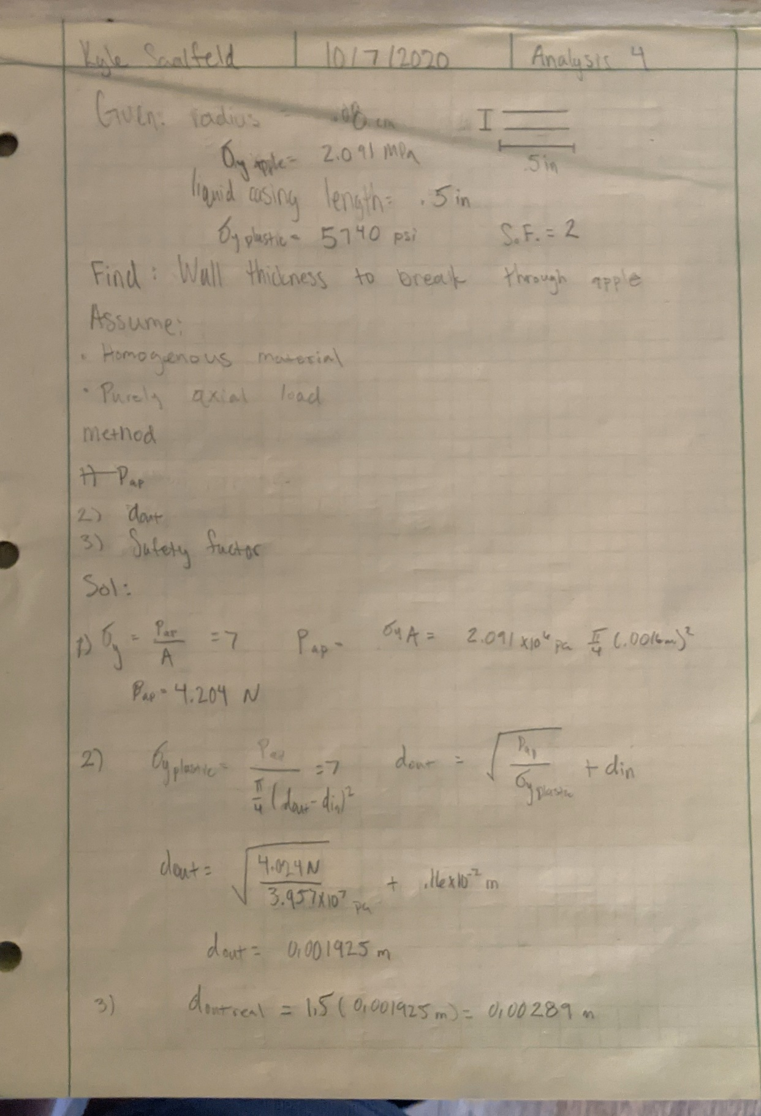

Appendix A-5- Handle outer diameter
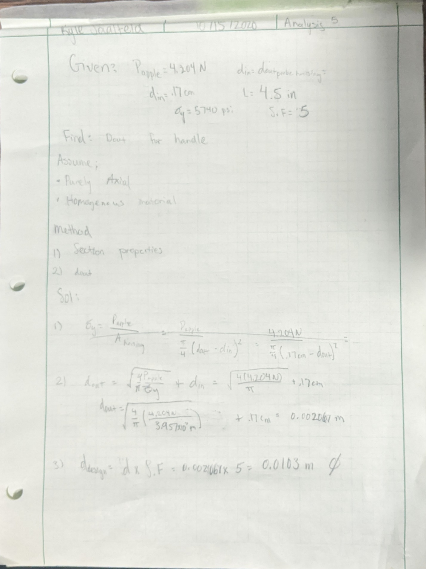
Appendix A6 - Screw diameter
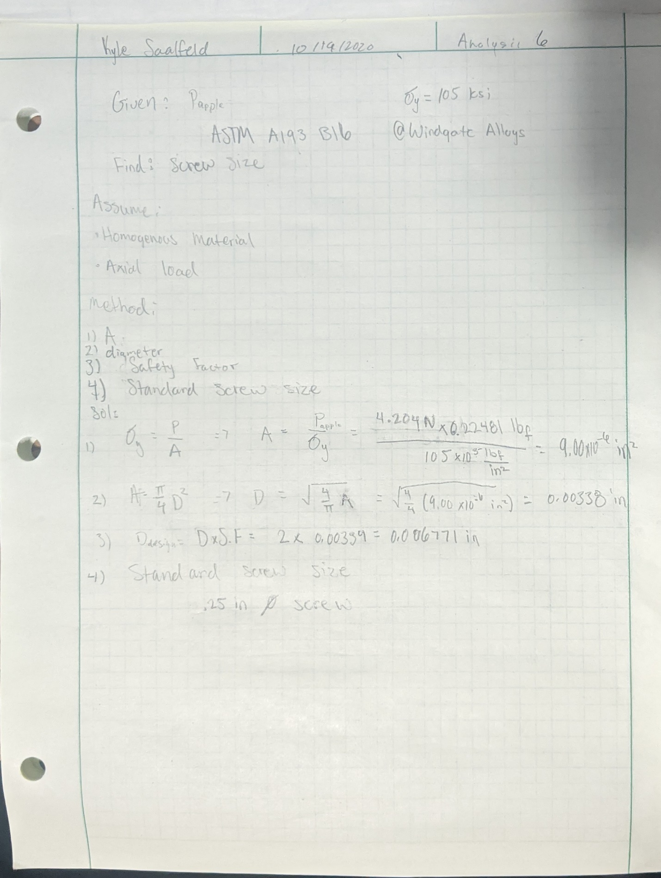
Appendix A-7- Weight Requirement of 20lbs 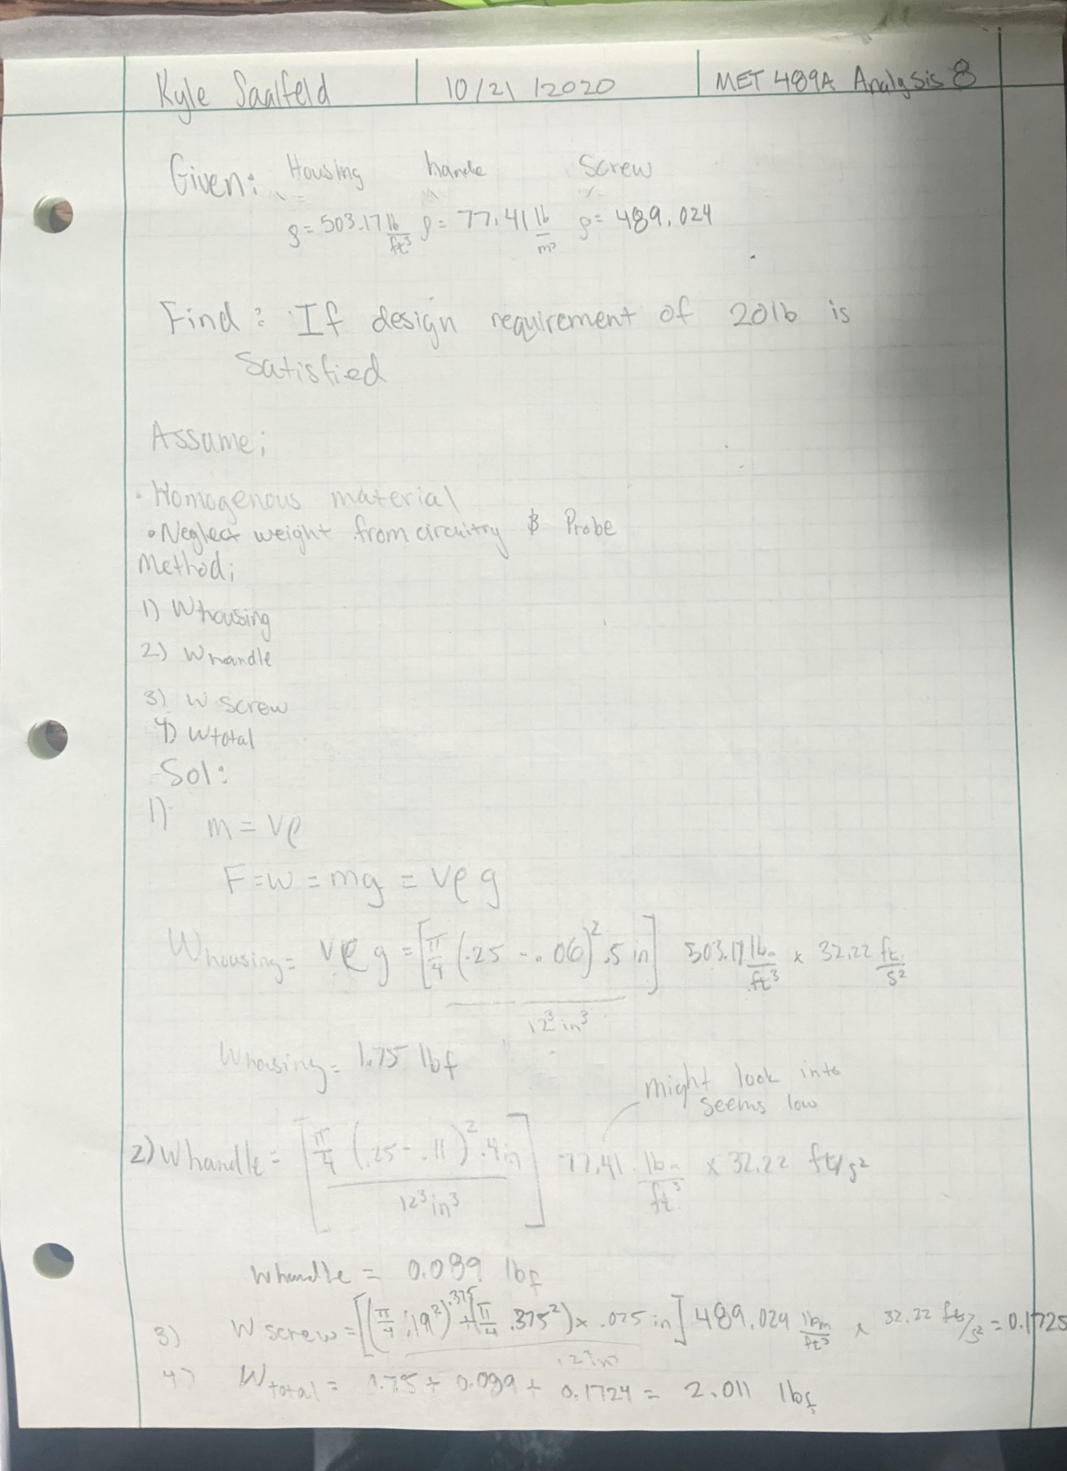

Appendix A-8- Equivalent screw engagement length 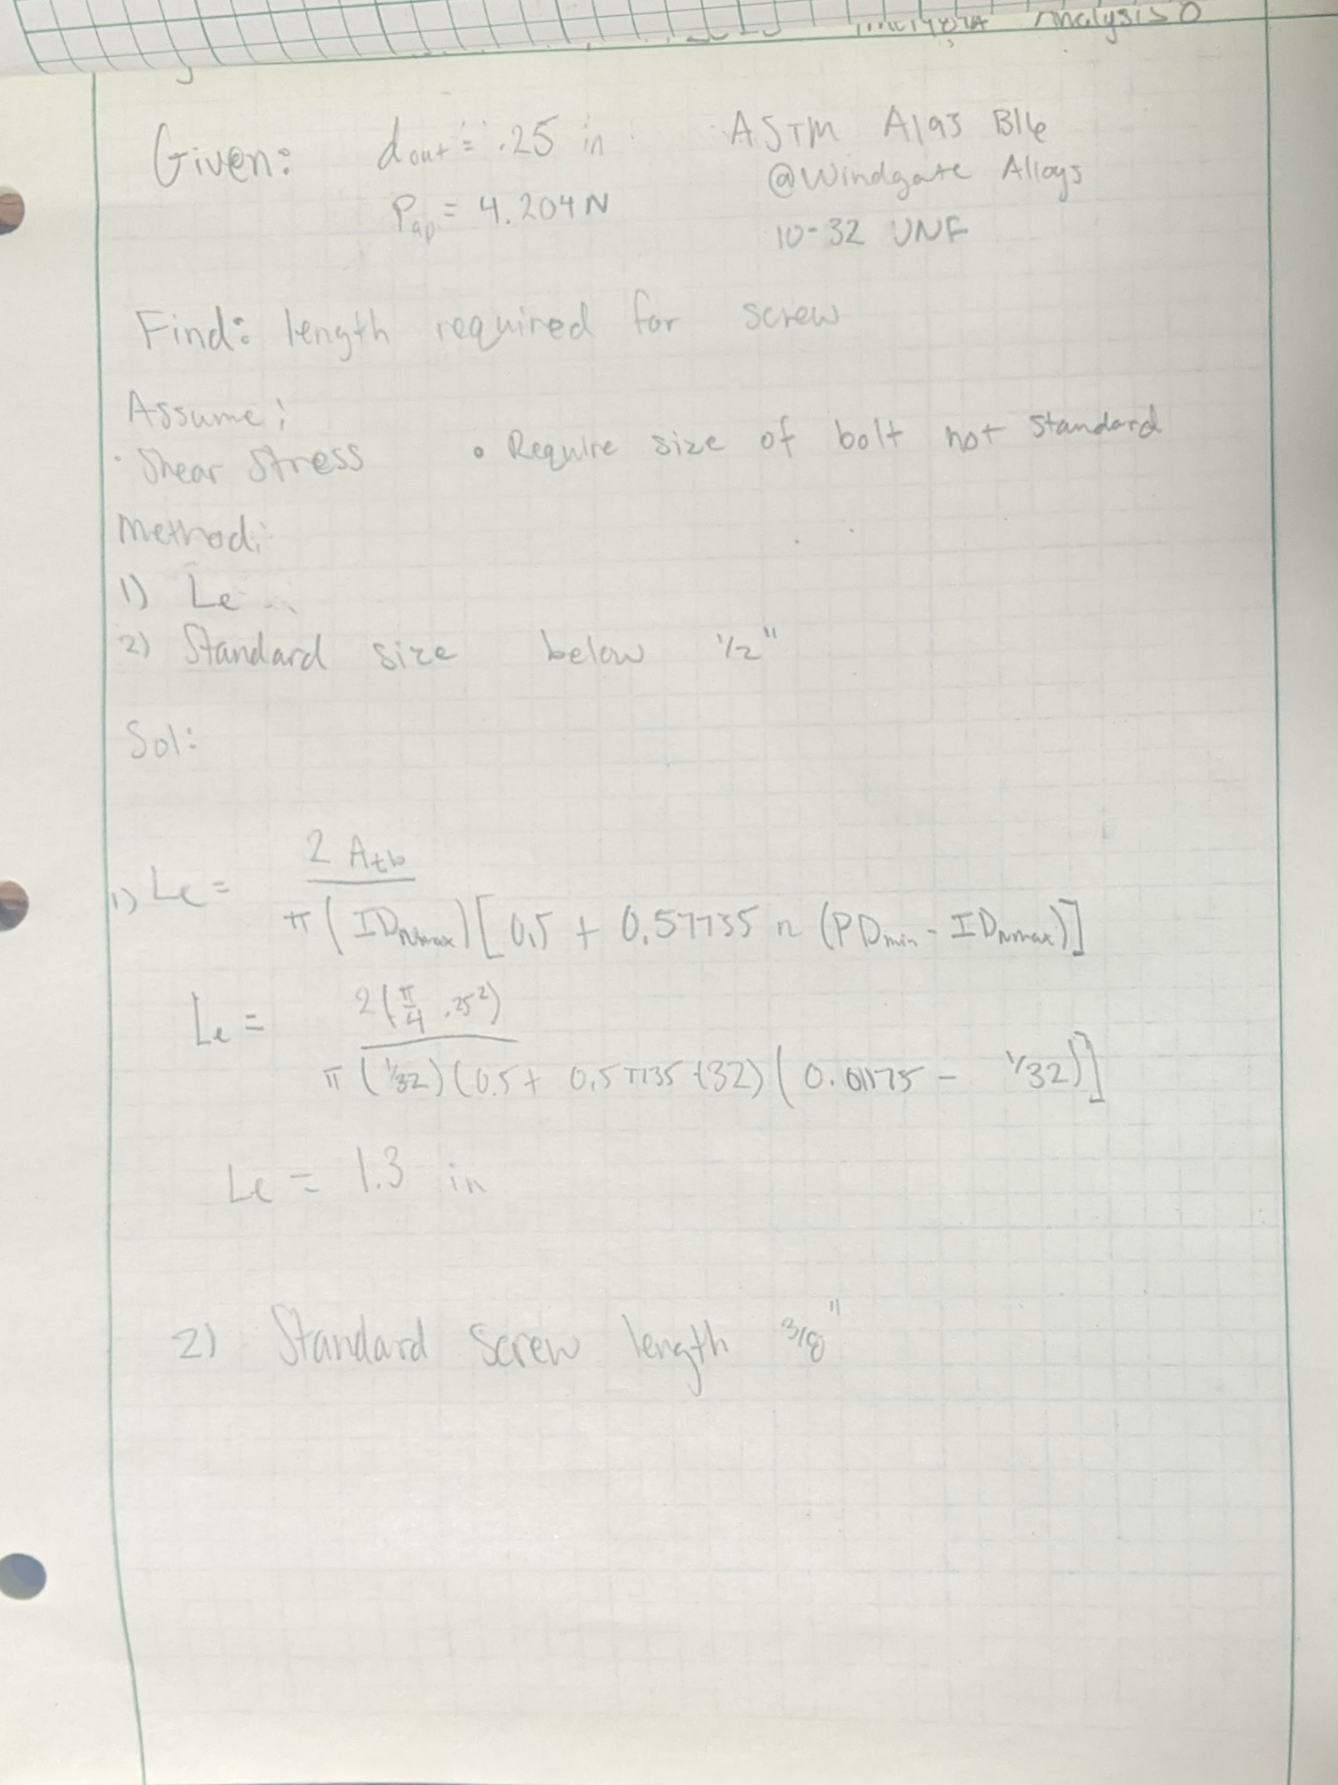
Appendix A-9- Bit spec for bread board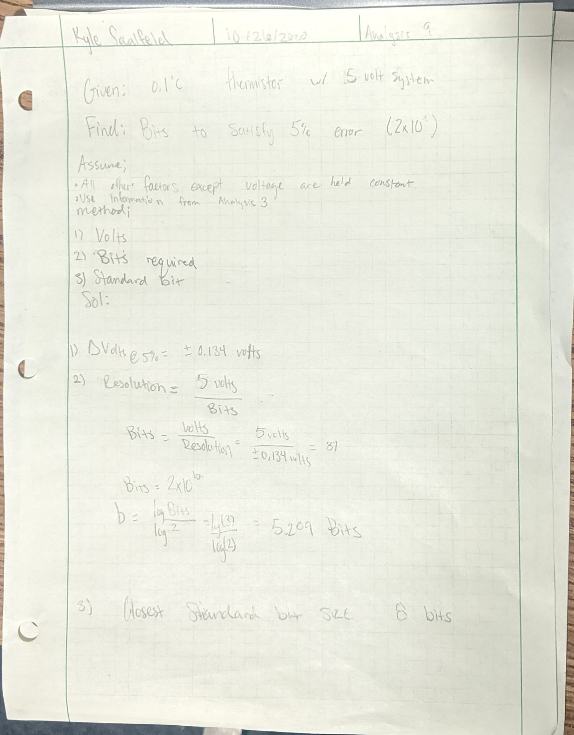
Appendix A-10- Resistors require to make Wheatstone bridge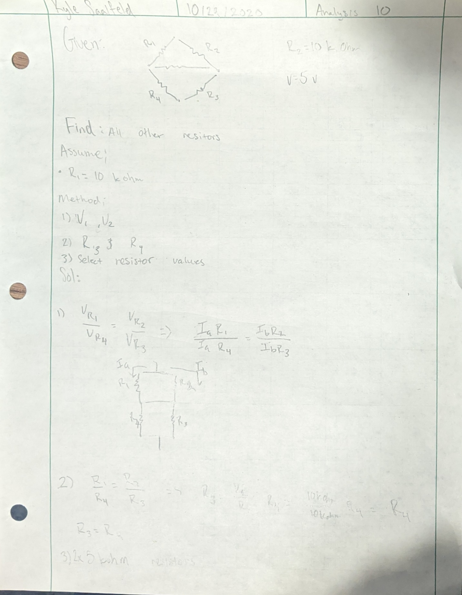

Appendix A-11 – Power supply needed to heat up thermistor
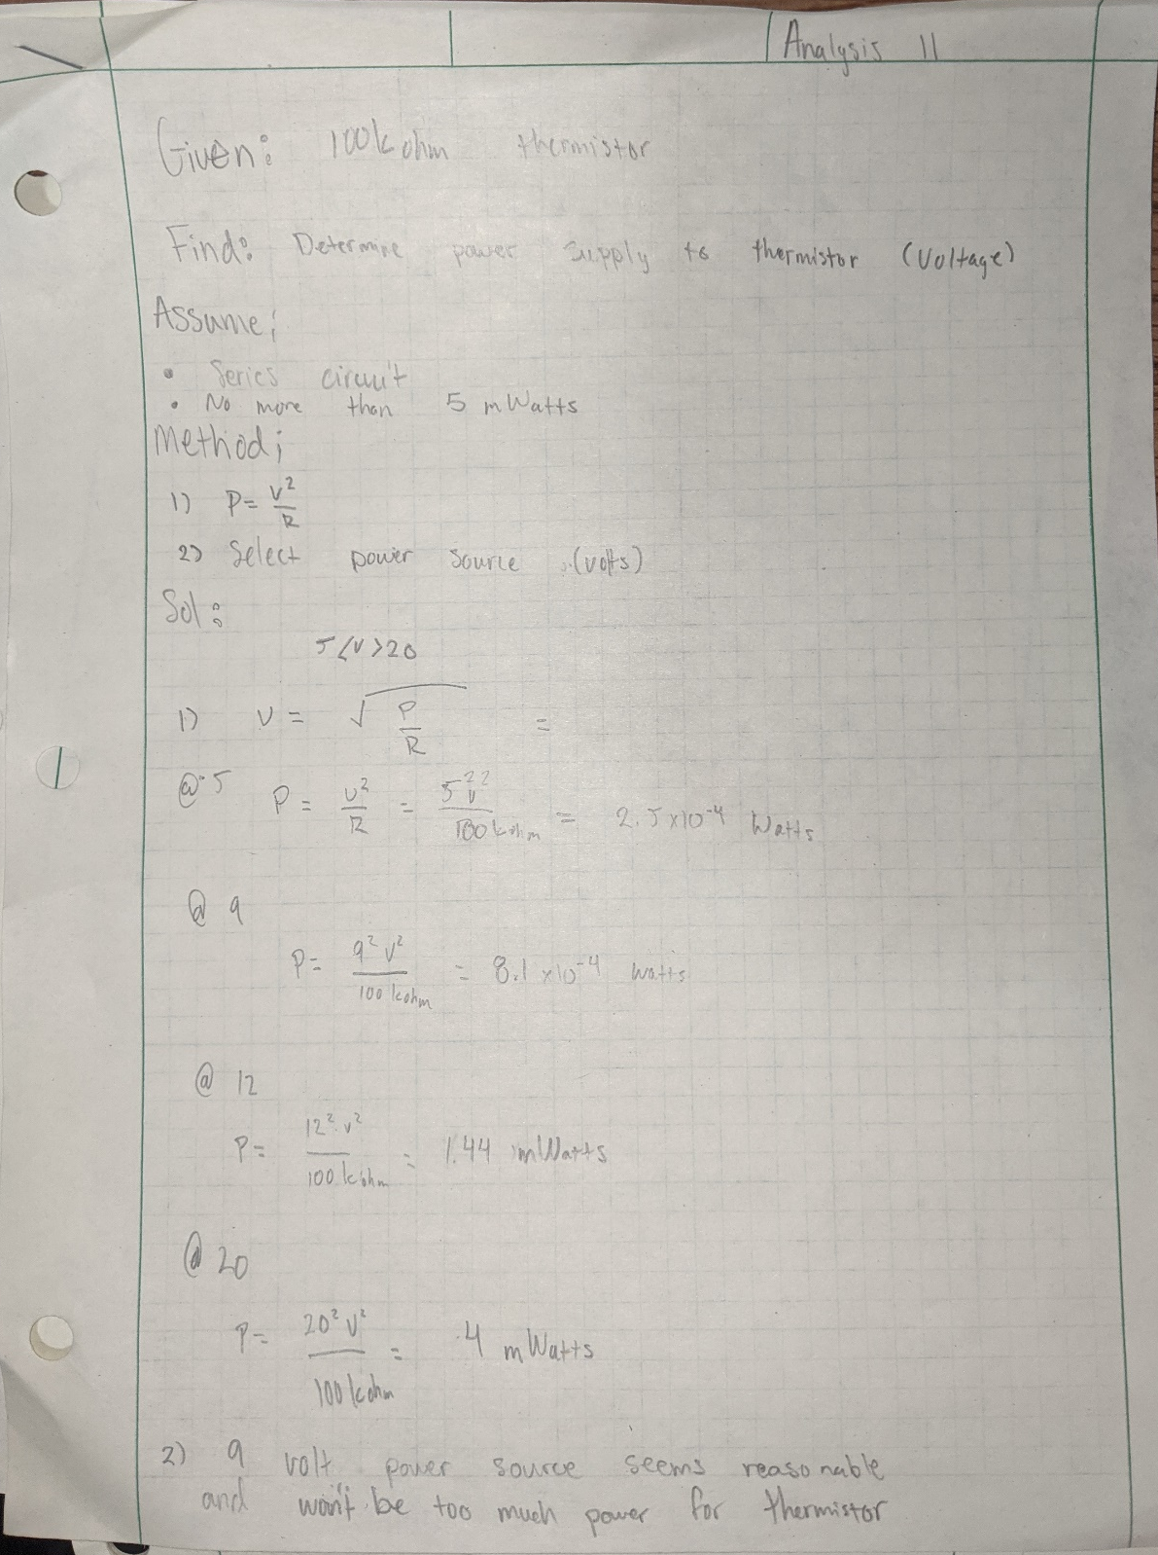

Appendix A-12- Required diameter with concentration factor for revised thermistor housing
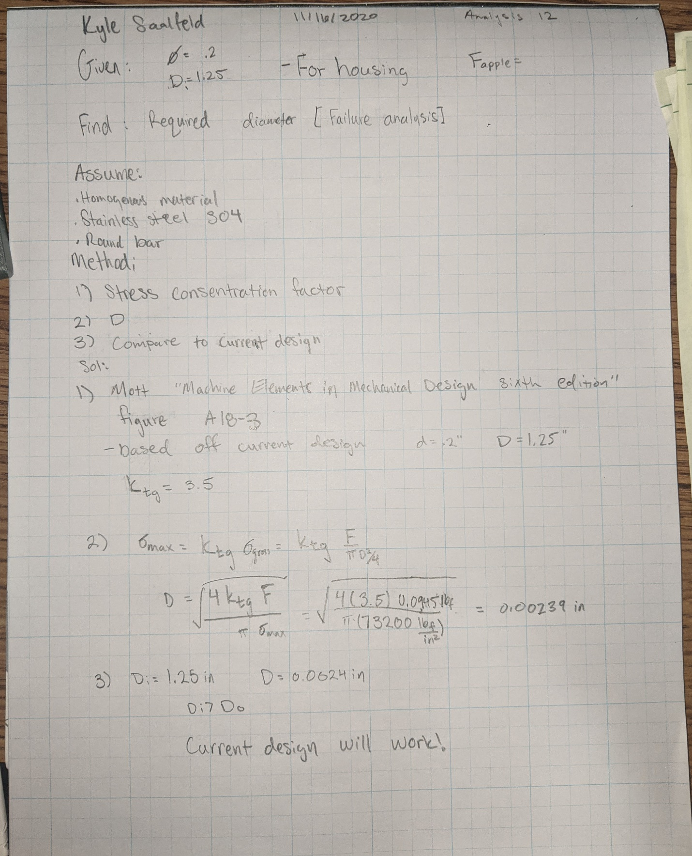
Appendix A-13- Tolerancing RC8 fit for probe housing and handle dimensions